Experiment: LINEAR CAPACITANCE METER

Name: Mansi Uniyal

Roll no.: 19EE10039

Date: 2/3/2021

* Objective:   
  A) To study the operation of an astable multivibrator using IC-555 (Part no. NE555)

B) To observe the deflection current variation with the capacitance CX connected at the output of the multivibrator.

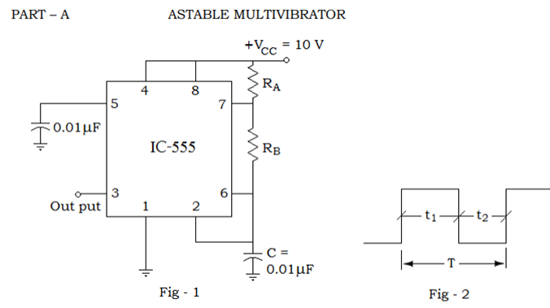

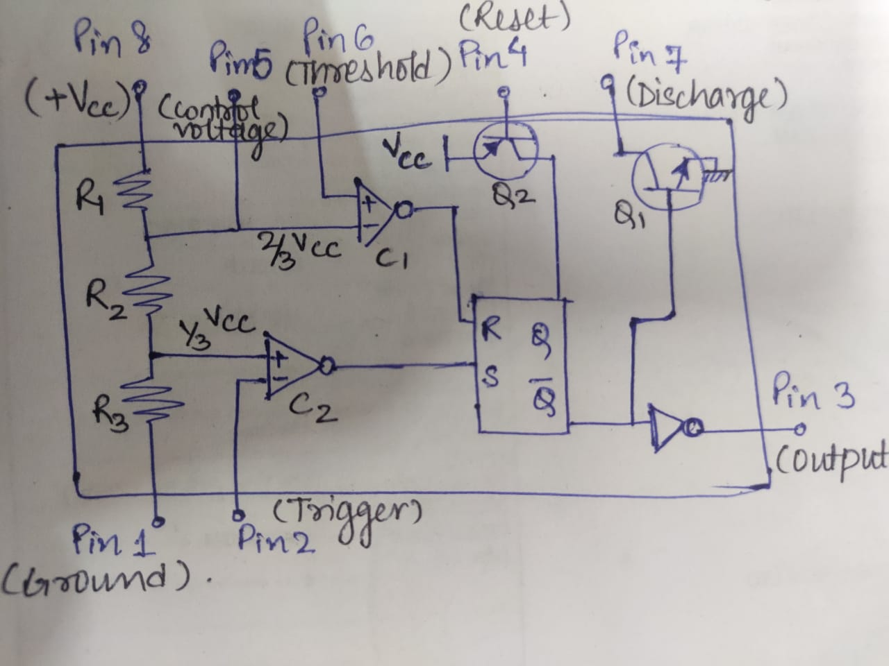

For a linear IC-555 chip used as an astable multivibrator:

ON period t1 = 0.693 (RA + RB).C

OFF period t2 = 0.693 RB.C

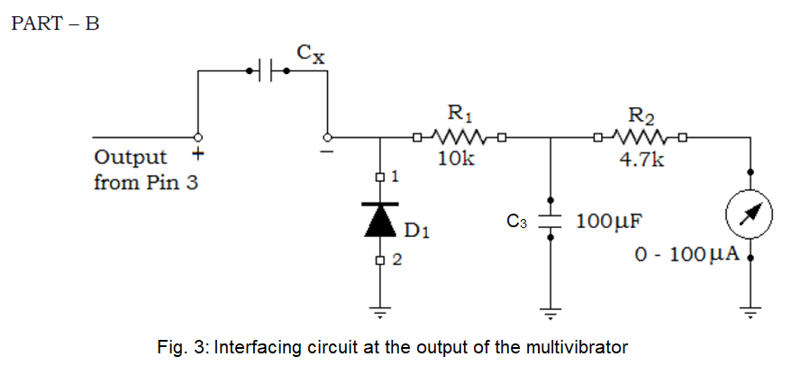

(1)

* Simulation Assignment:

1. Compute numerically the values of RA and RB for achieving a time period (T) of 10 ms and t1=7 ms. assuming C = 0.01 µF.

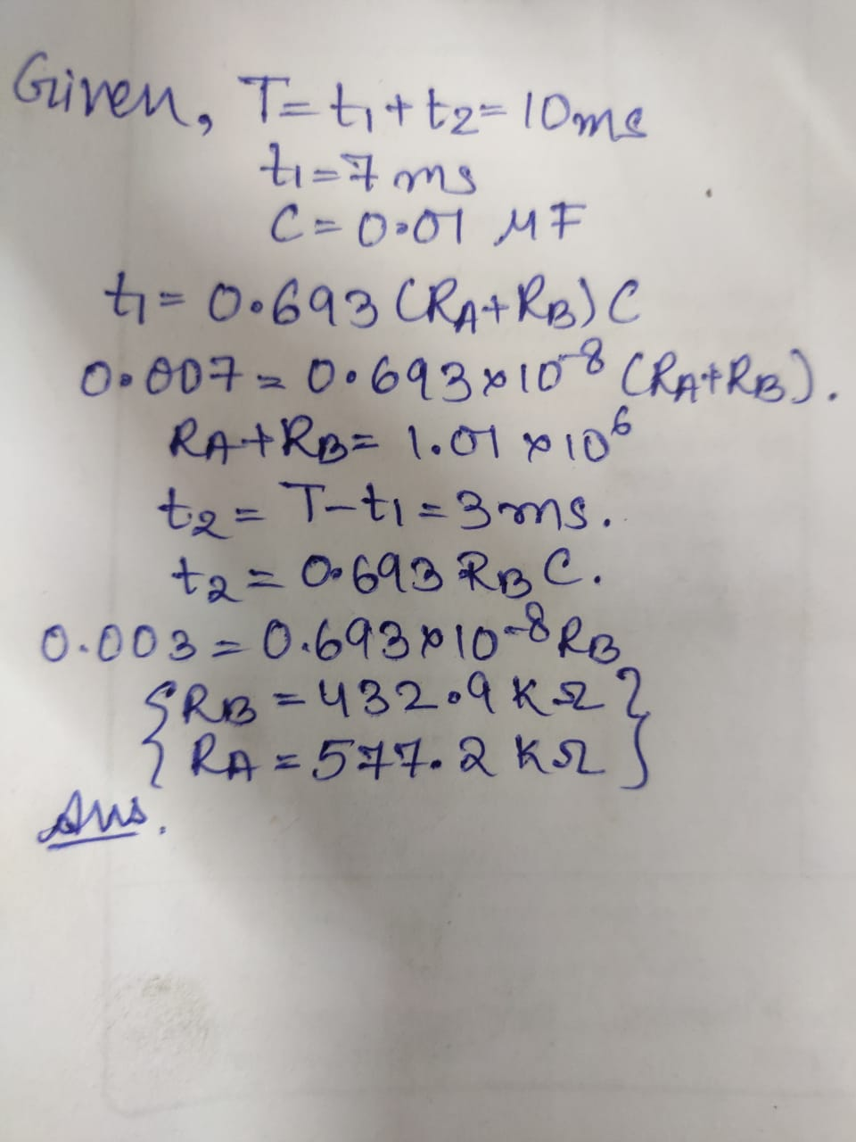

1. Draw neatly the following timer circuit in LTSpice. All the components should be chosen as ideal. Attach the screen-shot of the schematic.

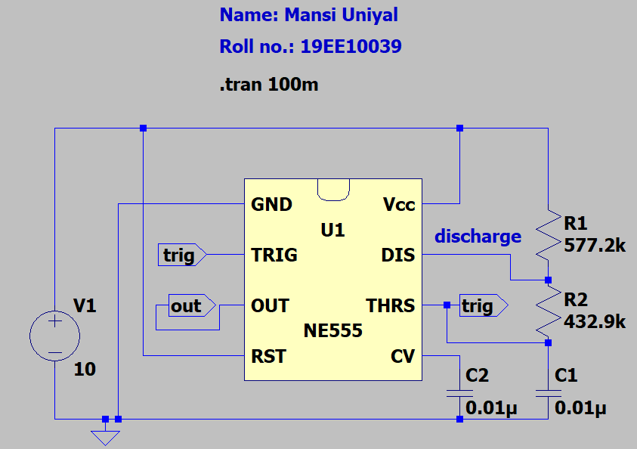

1. Using the computed values, construct the circuit. In simulated waveforms, measure the time periods t1 and t2, and attach the screenshot of the plot.

**Answer** Observed t1 = 7.030743 ms, t2 = 3.0004885 ms

Initially, it takes 4.733 ms because the capacitor is charging from 0 V to max value 20/3 V. Then alternatively 7ms and 3ms are taken as expected since the capacitor charging and discharging takes place between 20/3 V and 10/3 V.

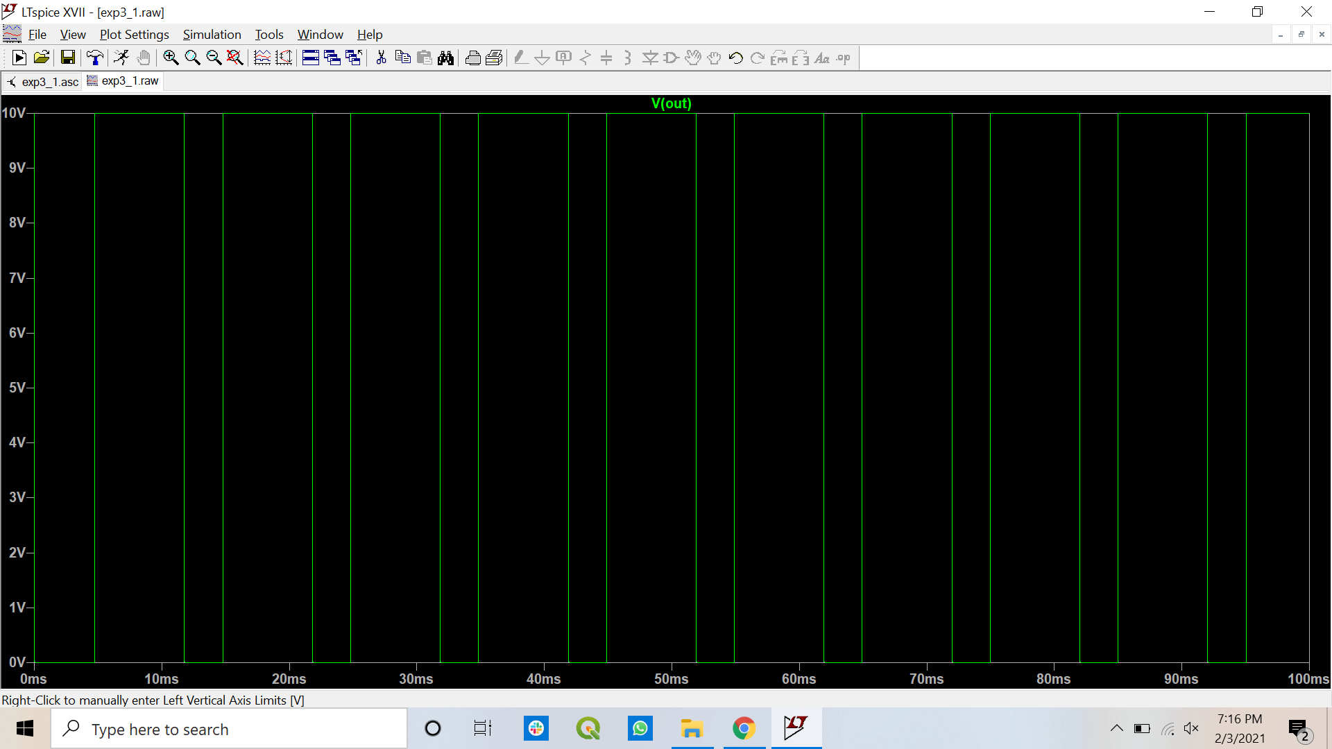

1. Add the interfacing circuit into the schematic. Connect a capacitor of 0.1 µF as CX and measure the current flowing through R2. Attach the screenshot of the current through R2.

**Answer** Iavg= 89.3 uA

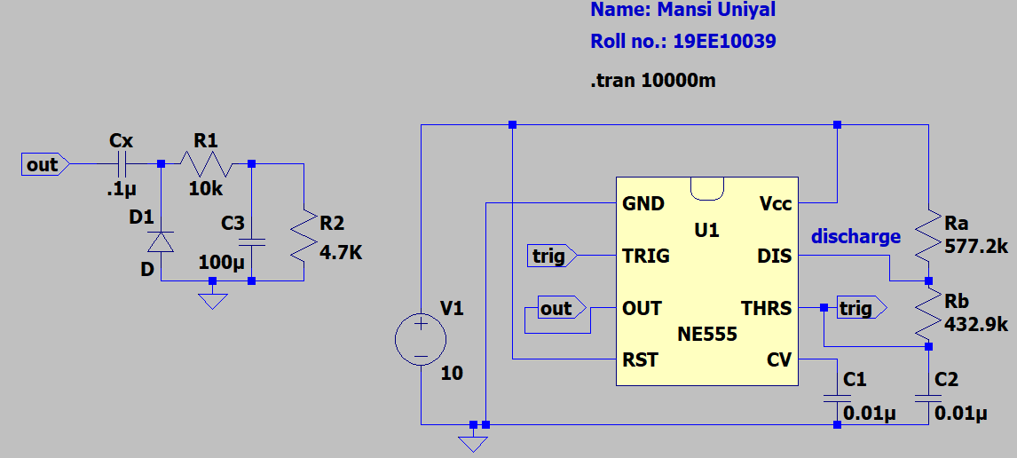

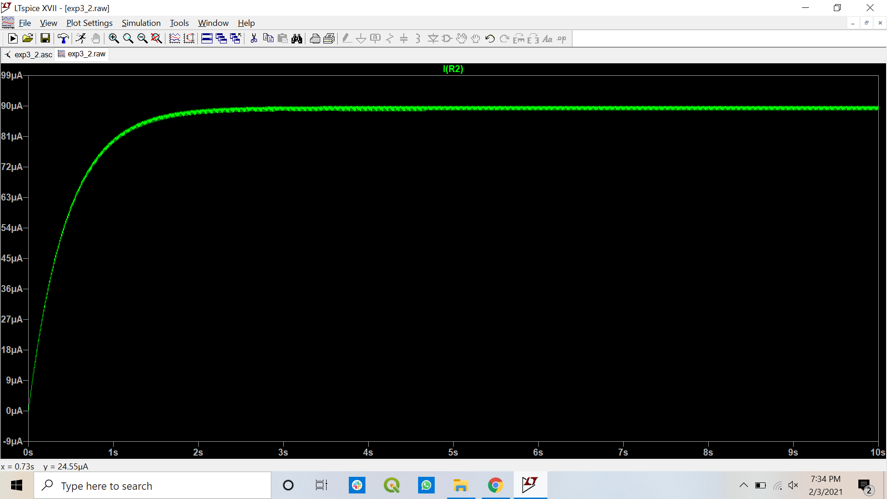

1. Now, decrease the capacitance value of CX in the range of 0.1 µF to 0.01 µF with a decreasing step of 0.01 µF and attach the screenshot of the current following through R2. Plot the current flowing through R2 versus capacitance values in a curve.

**Answer** As the value of Cx increases Iavg flowing through the resistor (ammeter) also increase.

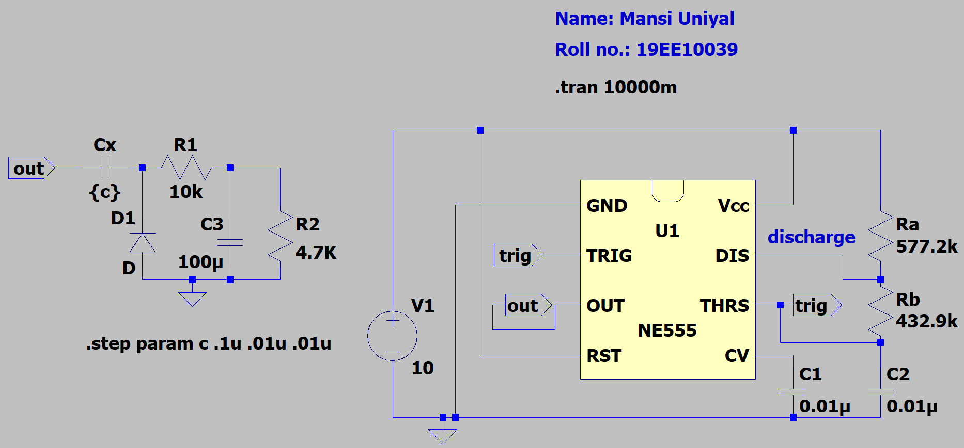

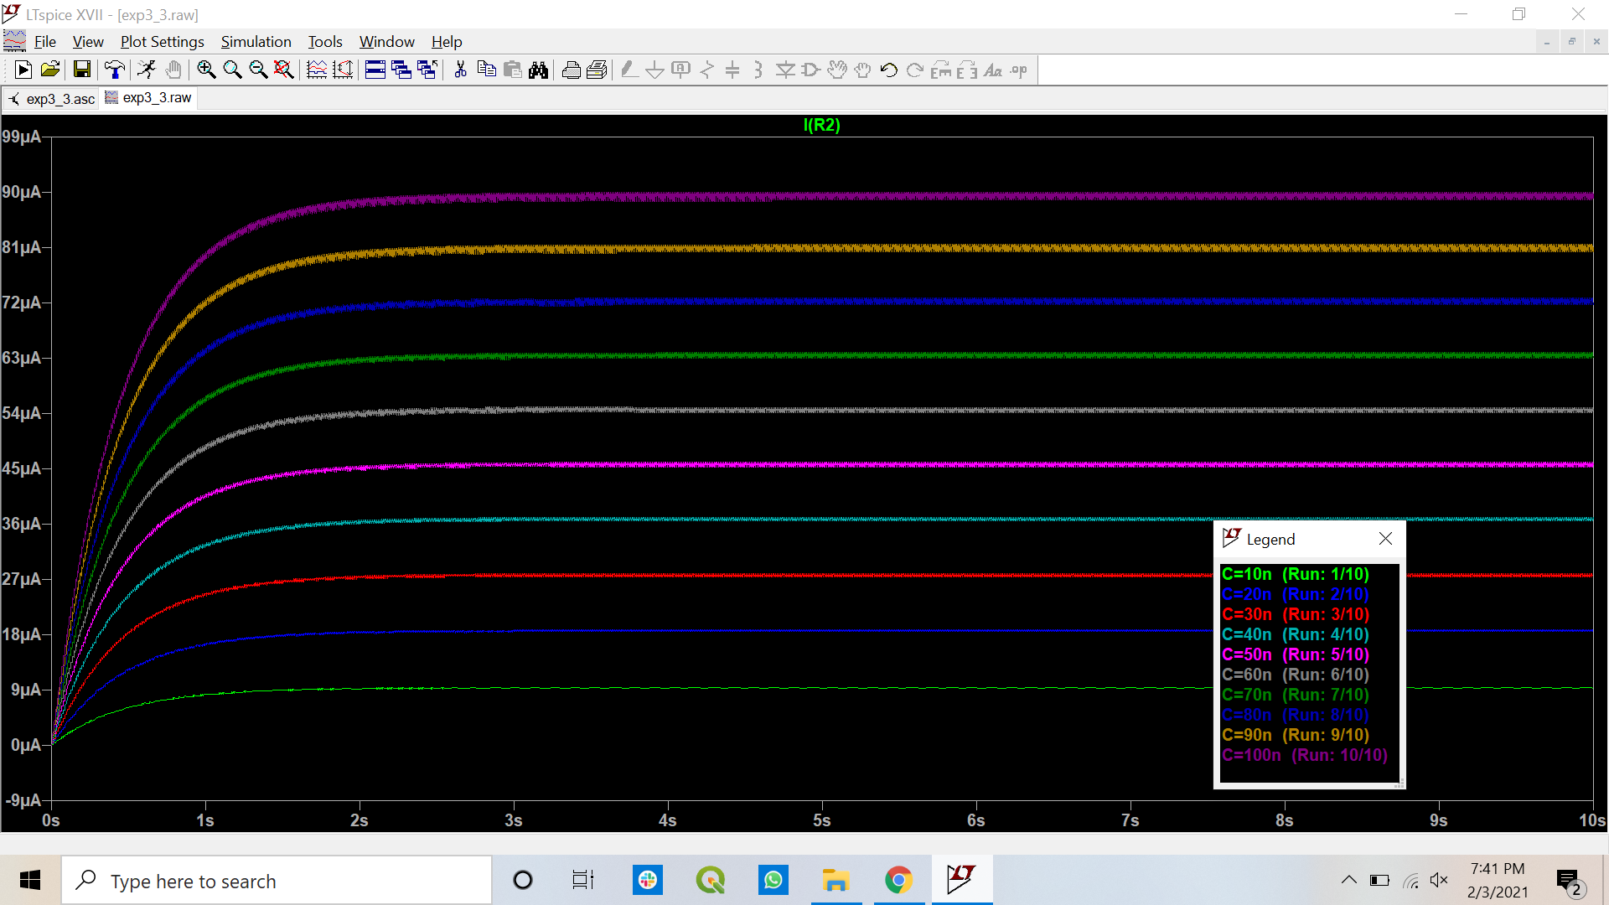

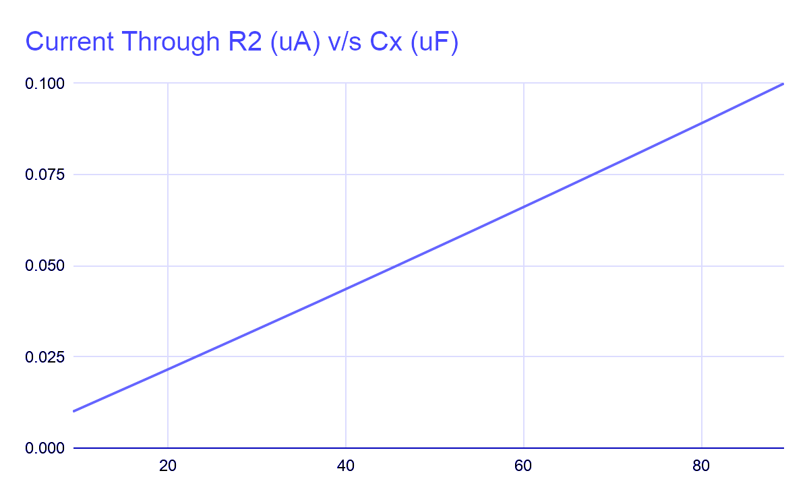

* Points to be discussed in brief:

1. Increase the voltage Vcc from 10 V to 15 V with a step of 1 V. Does the frequency change with the supply voltage in the astable multivibrator? Add a discussion.

**Answer** No, with increase the voltage Vcc from 10 V to 15 V with a step of 1 V there is no frequency change with the supply voltage in the astable multivibrator. This is because all the other parameters such as RA, RB, C, are kept constant which affect the time period T (t1 + t2). But, an increase in the amplitude of the voltage at the output, the amplitude of current at R2 is observed; with an increase in voltage (Vcc).

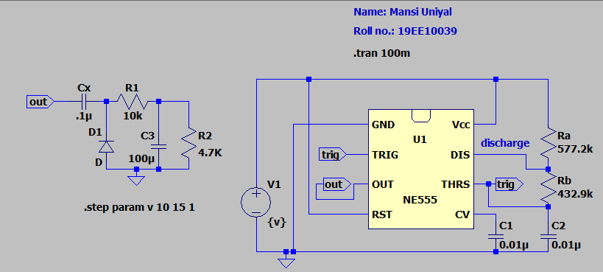

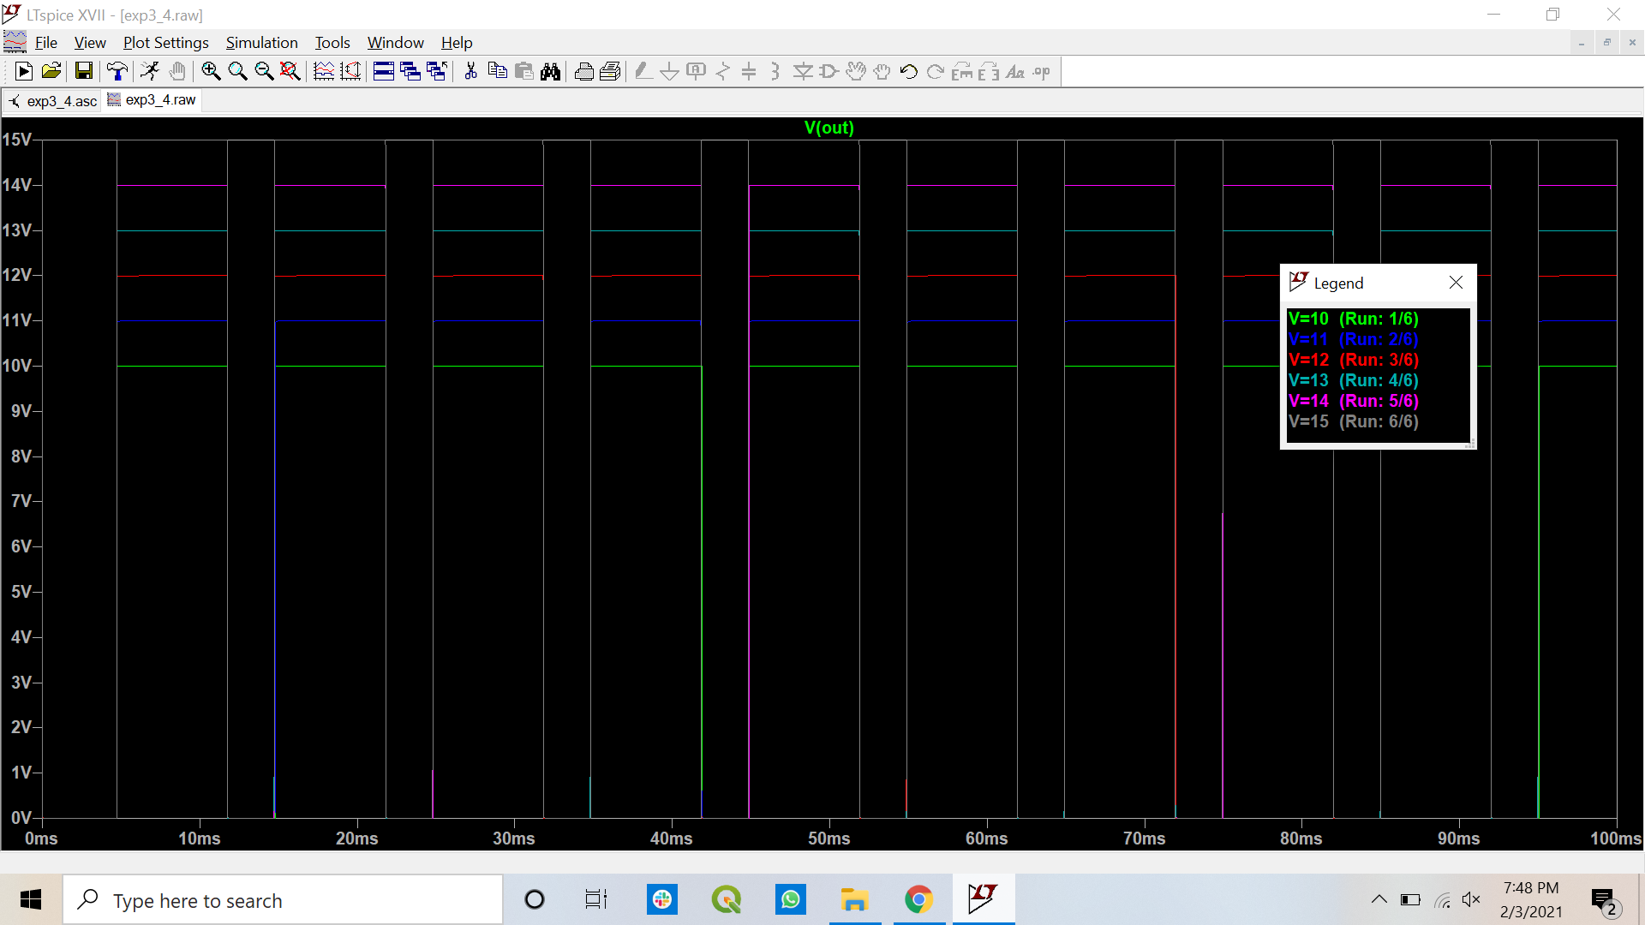

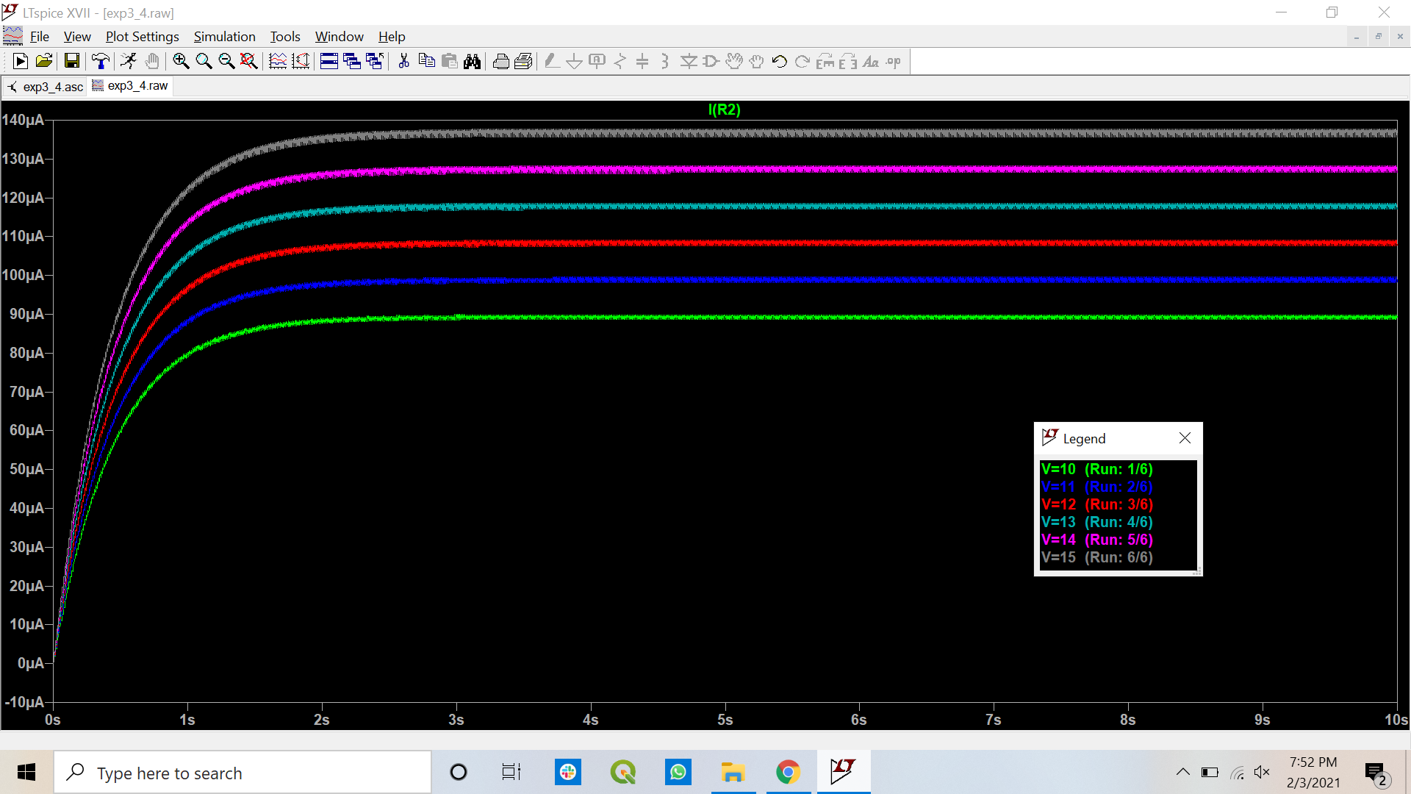

1. From the measured current through R2, calculate the theoretical value of CX using Equation (1). Does the theoretical value of CX have a good agreement with the chosen CX values? Add a discussion.

**Answer** Yes, the theoretical value of CX has a good agreement with the chosen CX values. However, it has been observed that as the CX increases the percentage error in the theoretical value of CX also increases. This can be considered due to the Junction Capacitances and Resistances in NE555 which consists of OpAm i.e. BJTs. The maximum percentage error in the value of CX comes out to be 10.7 %.

